Hans Jostlein 6/2//2005

Light Concentrators for the Braidwood Detector

Abstract:
In many PMT application one can use photomultiplier tubes (PMT’s) more effectively by concentrating light onto their photocathodes. This note looks at the geometry for the particular dimensions of the Braidwood detectors.
We find that, due to the large angular irradiance cone, significant concentration is likely not possible. In addition, the cones are so flat that their reflected light would make optical modeling of the detector extremely challenging.

Introduction
The Braidwood reactor neutrino experiment will look for electron neutrinos via their inverse beta decay signature of a positron and a neutron. Each of the four detectors is a 7 m diameter steel sphere, with a concentric acrylic sphere of 5.2 m diameter inside. The inner sphere is filled with liquid scintillator with added Gadolinium for neutron trapping. The outer volume is filled with an inert oil. One thousand PMT’s are mounted close to the steel vessel, pointing inward. The outer inert oil zone prevents positrons and secondary particles from neutrons from registering very close to PMT’s, where their response function is steep and ill defined.
The experiment will locate the event by analyzing the light distribution on the PMT’s. This works roughly like a center-of-mass analysis. The locating capability is important for assuring a well-understood fiducial volume and for rejecting background events.
To achieve good locating and good energy resolution, the PMT coverage is 25 % by area, requiring 992 PMT’s.
This is an expensive component of the detectors.
This note examines if the same level of coverage can be achieved with fewer PMT’s and light concentrators.

How Light Concentrators Work
Liouville’s theorem states that the phase space of light (i.e. the integral over angles and dimensions) can not be compressed, except under special conditions such as wavelength shifting. When designing light concentrators, one aims to increase the width of the angular distribution of the incident light, while reducing the illuminated area or, equivalently, one aims to increase the area over which incident light is collected by increasing the width of the angular distribution of light hitting the photo detector.
This task becomes more difficult if the incident light is already covering a large angular cone. For the Braidwood detectors, each PMT sees the acrylic sphere under a cone half angle of 52 degrees, as Fig. 1 shows:

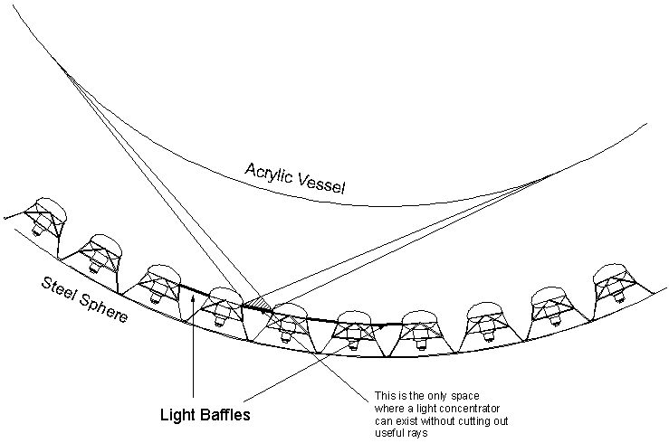Fig. 1 Incident light Geometry for a Braidwood PMT

The small hatched triangle is the only region where light concentrators can be placed without intercepting useful direct light from the acrylic sphere.
(It does not matter for the present discussion but we note that we assume light baffles between PMT cathodes to eliminate light from the shell beyond, which converts gamma rays from the steel vessel and beyond.)
The most effective shape of a light concentrator in this allowed space would be a cone as shown in Fig 2:

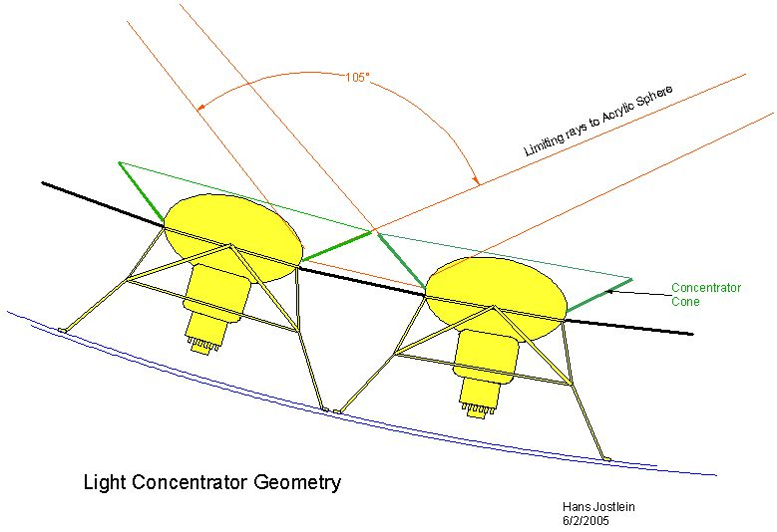
Figure 2: A possible light cone shape

The green lines indicate the shape of the light cone. It will reflect light of near normal incidence into the sides of the PMT’s, where the cathode wraps around. It is not easy to estimate the amount of extra light (not reflected by the glass) thus added.

Other Considerations
By drawing a few light rays on Fig 2 one can convince oneself that much of the light that strikes the cones gets reflected back across the sphere, and will be detected there, or reflected again.
This extra light will help the determination of the total amount of light, hence the energy, in each event. It will, however, distort the light distribution among the PMT’s in ways that are difficult to model, let along de-convolve. If one remembers that 75% of the area would be covered with reflecting surfaces, one can appreciate the difficulty of this task.
A similar difficuylty presents itself if one tries to perform optical response calibrations with discrete light sources, or even small radioactive sources.

Conclusion
Due to the large intrinsic angular width of the useful light it is unlikely that large gains can be realized from reflective light concentrators.
More importantly, it seems that the presence of the large required reflective surfaces would make event location confusing and makes calibrations very difficult to understand.

